Networking Task 01: Understanding Your Network Environment

Part A: Network Information
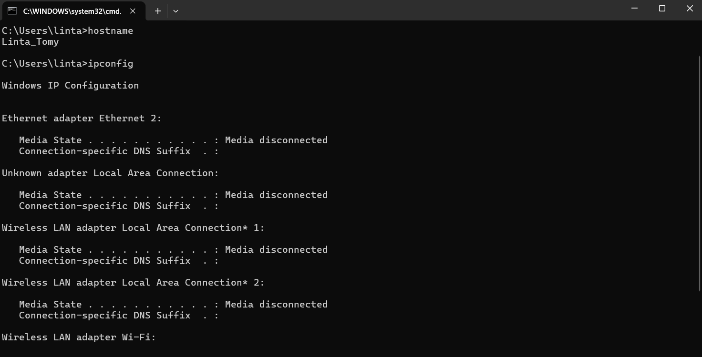

Part B: Basic Networking Concepts
1. What is an IP Address?
An IP address is a unique number assigned to a device on a network. This lets devices find and talk to one another online or on a local network. Like a house address, it makes sure data gets to the right place.
Example: 192.168.1.10 or 2001:db8::1

2. What is a MAC Address?
A MAC address is a unique code made by the manufacturer for each network interface card. It lets devices communicate on a local network and helps identify specific machines, so devices can be found and communicated with properly.
Example: 00:1A:2B:3C:4D:5E
Difference from IP:
- IP Address can change based on the network.
- MAC Address is usually permanent and tied to the hardware.

3. What is a Default Gateway?
A Default Gateway is the device, usually a router, that links a local network to others, like the internet. So when your device needs to send info beyond its network, it sends it to the default gateway.
Example: If your computer's IP is 192.168.1.5, the default gateway might be 192.168.1.1 (your router).

4. What is DNS?
DNS, or Domain Name System, changes easy-to-remember domain names into IP addresses. Computers need these numbers to talk to each other, so DNS lets us use names instead of tough-to-recall numbers when browsing the web.
Example: When you type www.google.com, DNS converts it to Google's IP address so your browser can connect to the website.

5. Difference Between Public IP and Private IP
Public IP Address | Private IP Address
Used on the internet and globally unique. | Used within a local network.
Assigned by an Internet Service Provider (ISP). | Assigned by a router or network administrator.
Can be accessed from anywhere on the internet. | Cannot be accessed directly from the internet.
Example: 8.8.8.8 | Example: 192.168.1.10
Used for communication over the internet. | Used for communication within homes, offices, and organizations.

Part C: Create a Basic Network Diagram
